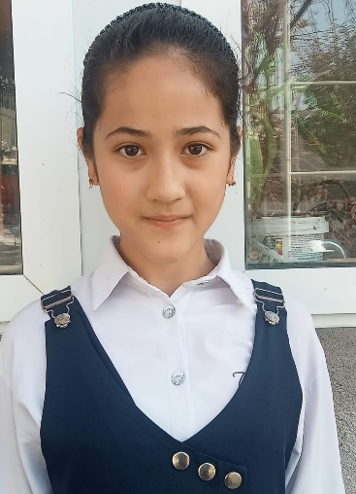

ИСАКОВА Шахруза,

№42 Фурқат атындағы жалпы орта мектебінің

5-сынып оқушысы.

Жетекшісі: АКИМОВА Ниязай Абдипаттаевна,

Ағылшын тілі мұғалімі.

Түркістан облысы,Сайрам ау даны

**I THINK ABOUT ONE OF MY TEACHERS...**

A teacher is an example of a student. There are millions of teachers in the world. Everyone imagines a great teacher differently. Some say that a great teacher is strict, while others say that a great teacher is gentle. In my opinion, the best teacher should be able to find a way to a child's heart, not in a harsh manner, not in a soft manner. Modern students have high demands on teachers. There are conditions such as not to give homework, not to ask for homework, not to fight. But if the teacher fulfills all these requirements, teachers will not be teachers.

My favorite teacher's name is Niyazai Akimova. He can be proud of his wit and intelligence. I am very grateful to my aunt. She taught us the secrets of the English language. She told us many things that we did not know. Niyazai Akimova takes us to many competitions and cares about our future. She works hard for us to be good in the future, get the right education, and get on the right path. My teacher has a pure soul and a good heart. He is a white person who found a way to my heart. This teacher is very generous, has a pure heart and no evil thoughts. He has many achievements, but he does not brag much.

Our aunt Niyazai Akimova is the recipient of many praises.

I personally admire the teachers. They rush to school before dawn or sunrise. For them, school is their second home. If it wasn't for these teachers, I think we would be equal to monkeys now. Shows the world. They are enough for everything.

Take advantage of this moment to tell my aunt: You are a wonderful soul in life. Stay healthy and send thousands of students from your hands. Keep laughing and playing and being a wonderful and beloved teacher among us. We are very grateful to you!